* Creating simple – Hellow-world Python – lamda

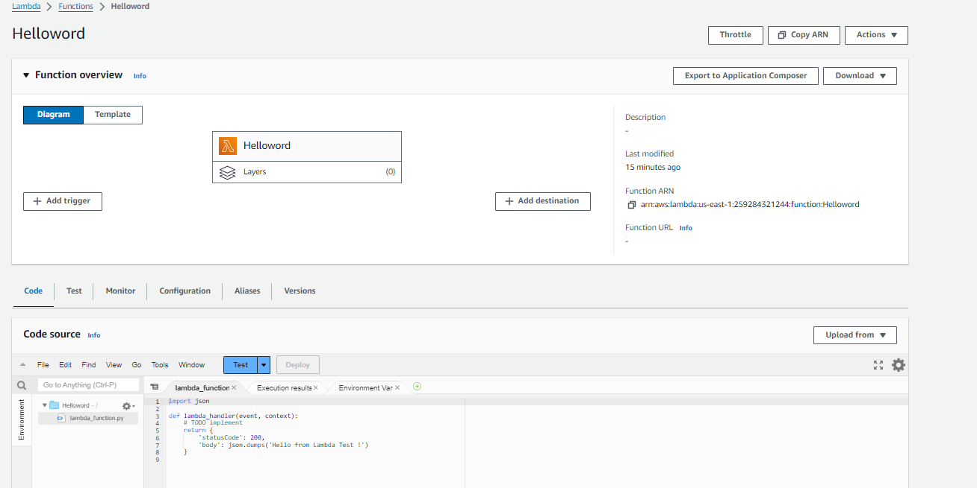

* Create SG to route the traffic from VPC by selecting a execute-api – Full access on policy

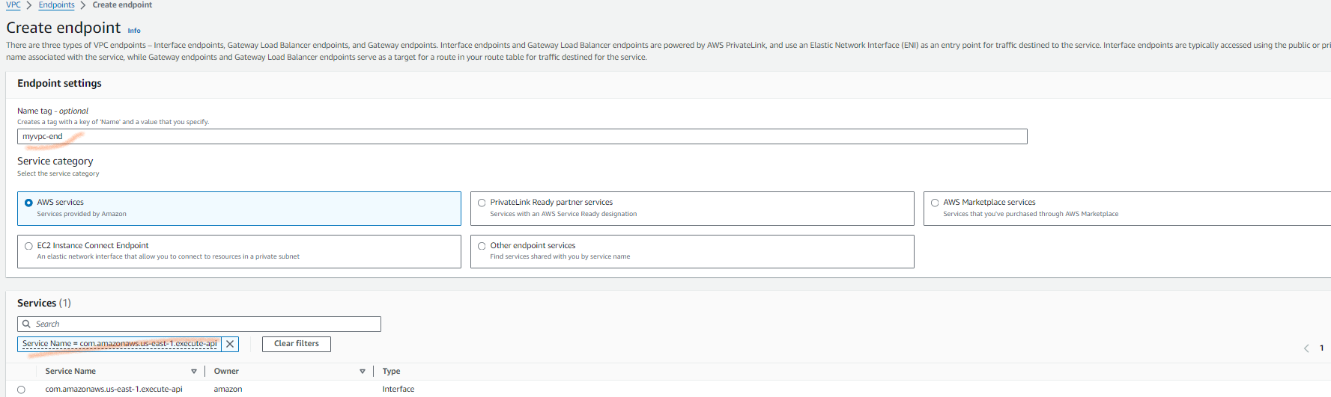

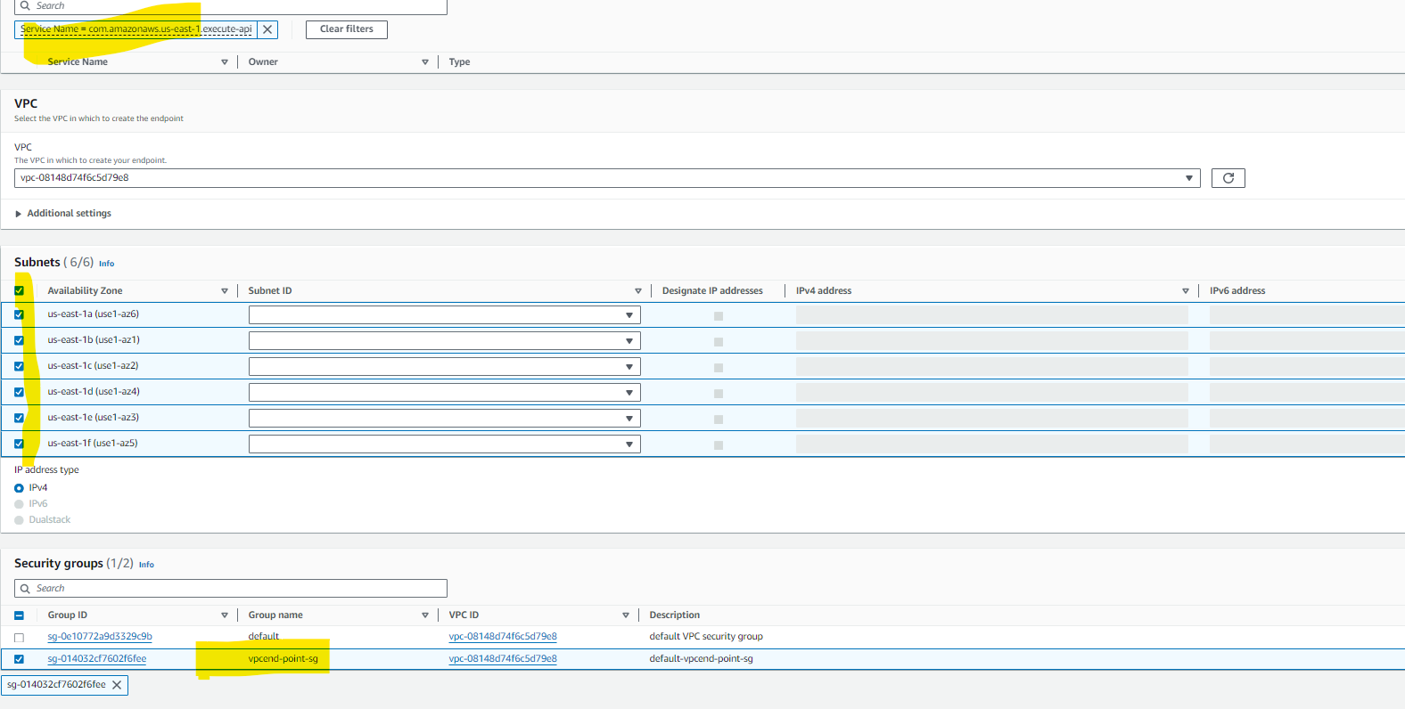

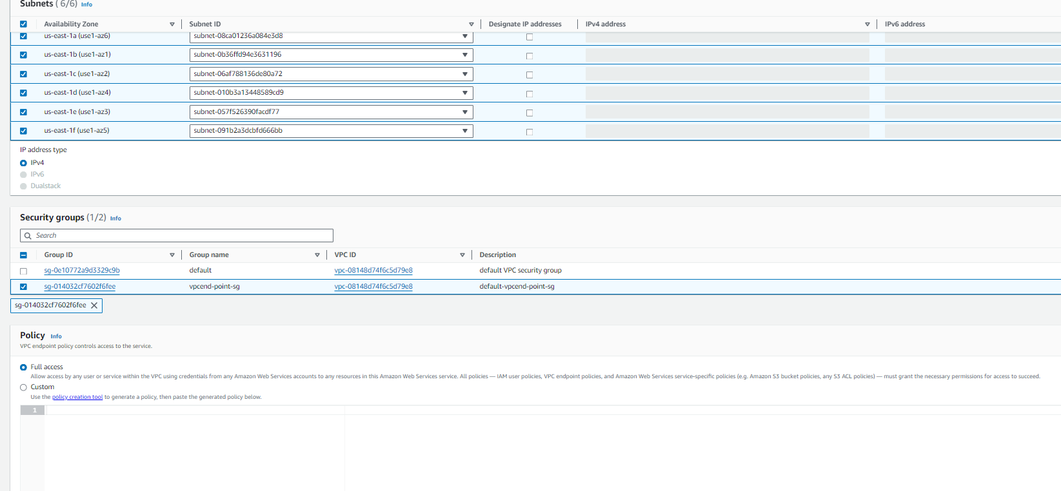

VPC End-point id is accessible - vpce-0f7029c7f28de4b7d

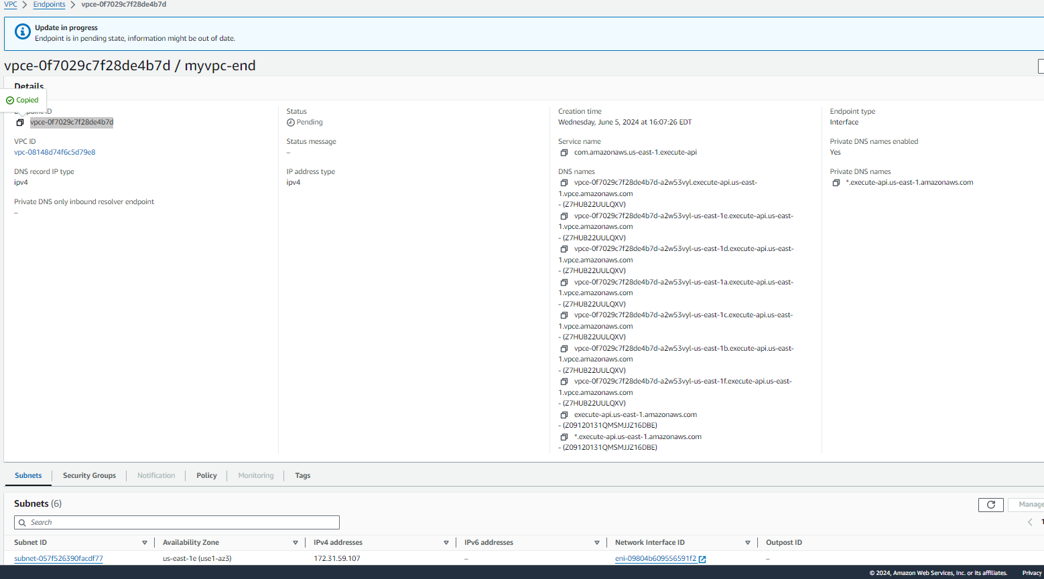

Create REST-API-Private

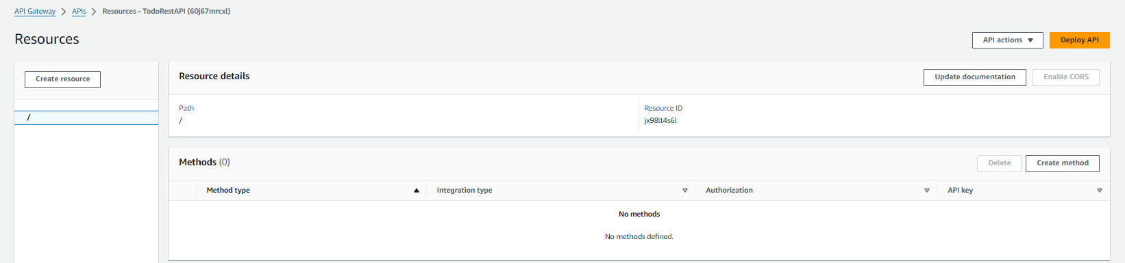

Create a get method and test lamda created

